
Bansilal Ramnath Agarwal Charitable Trusts'
Vishwakarma Institute of Technology, Pune - 37.
(An Autonomous Institute Affiliated to Savitribai Phule Pune University)
Department of Computer Engineering

SY OS Course Lab Assignment Submission:
College Name: Vishwakarma Institute Of Technology
Course Name: Operating System (OS)
Course Code: CS2310
Project Phase: Multiprogramming Operating System (MOS) - Phase 2 Simulation
Div: SY K
Branch: CS
Student Name: Siddesh Suresh Shirote
Roll Number: 27
PRN: 12412427
Date of Submission: 03/05/2026

Project Title:
Multiprogramming Operating System (MOS) Phase-2: Simulation with Paging, Interrupt Handling, and Error Management
Aim
To simulate the advanced functioning of an operating system (Phase-II) using paging, virtual memory, interrupt handling, and error detection mechanisms.
Objectives: -
- To implement paging and virtual memory concepts.
- To simulate address mapping from Virtual Address (VA) to Real Address (RA).
- To implement interrupt handling using SI, PI, and TI.
- To detect and handle errors such as operand error, opcode error, and page faults.
- To simulate Process Control Block (PCB) and job execution.
- To implement time limit and line limit constraints.
Theory: -
A Multiprogramming Operating System (MOS) allows multiple programs to reside in memory and execute by sharing CPU resources. In Phase-2 of this project, advanced concepts such as paging, address mapping, and interrupt handling are introduced to simulate a more realistic operating system.
This phase focuses on memory management using paging, handling program errors, and enforcing execution limits using time and line counters.
1. Machine Specifications (The Virtual Machine): The system simulates a computer with the following configuration:
- Memory: 300 memory locations (30 frames × 10 words each), where each word stores 4 characters.
- Registers:
- IR (Instruction Register): 4 bytes, stores the current instruction.
- IC (Instruction Counter): 2 bytes, points to the next instruction.
- R (General Purpose Register): 4 bytes, used for temporary storage.
- C (Toggle): 1 byte, condition flag ('T' or 'F').
- PTR (Page Table Register): Points to the page table in memory.
- TTC (Total Time Counter): Tracks execution time.
- LLC (Line Limit Counter): Tracks number of output lines.

2. Paging and Address Mapping:
- Memory is divided into frames, and programs are divided into pages.
- Each job has its own page table stored in memory.
- Virtual Address (VA) is converted into Real Address (RA) using the page table.
If a page is not present in memory:
- A Page Fault (PI = 3) is generated.
A page fault is considered valid only for GD and SR instructions, otherwise it results in termination.
3. Instruction Format & Set: Each instruction consists of 4 characters (2 for Opcode, 2 for Operand address).
- LR xx: Load register with memory value.
- SR xx: Store register value in memory.
- CR xx: Compare register with memory.
- BT xx: Branch if condition is true.
- GD xx: Read data into memory.
- PD xx: Write data to output.
- H: Halt execution.
4. Interrupt System:
The system uses three types of interrupts:
- Service Interrupt (SI):
  - SI = 1 → Read
  - SI = 2 → Write
  - SI = 3 → Terminate
- Program Interrupt (PI):
  - PI = 1 → Operation Code Error
  - PI = 2 → Operand Error
  - PI = 3 → Page Fault
- Time Interrupt (TI):
  - TI = 2 → Time Limit Exceeded
5. Error Handling:
Code | Error
0 | No Error
1 | Out of Data
2 | Line Limit Exceeded
3 | Time Limit Exceeded
4 | Operation Code Error
5 | Operand Error
6 | Invalid Page Fault

6. Process Control Block (PCB):
Each job is associated with a PCB containing:
- Job ID
- TTL (Total Time Limit)
- TLL (Total Line Limit)
- TTC (Time Counter)
- LLC (Line Counter)
This structure helps manage job execution and enforce limits.

Algorithm / Execution Flow: -
- LOAD:
Open the input file and read lines sequentially.
- If $AMJ is found, initialize PCB and allocate frame for page table.
- Load program into memory frame-wise and update page table.
- START EXECUTION:
Upon reading $DTA, set IC = 00 and call EXECUTEUSERPROGRAM.
- EXECUTE USER PROGRAM (Fetch-Decode-Execute):
- Fetch: Load instruction from memory into IR using address mapping.
- Increment: IC = IC + 1.
- Decode: Identify operation from opcode.
- Execute: Perform instruction.
- If GD, PD, or H is encountered, generate interrupt and call MOS().
- MASTER MODE (MOS):
Handle interrupts based on priority:
Priority Order: PI > TI > SI
- SI Handling:
- SI=1 → Read data into memory
- SI=2 → Write data to output
- SI=3 → Terminate job
- PI Handling:
- Opcode Error → Terminate
- Operand Error → Terminate
- Page Fault → Allocate frame if valid, else terminate
- TI Handling:
- Time limit exceeded → Terminate
- SIMULATION:
- Increment TTC
- If TTC == TTL → TI = 2
- If any interrupt occurs → call MOS()

Flowchart: -
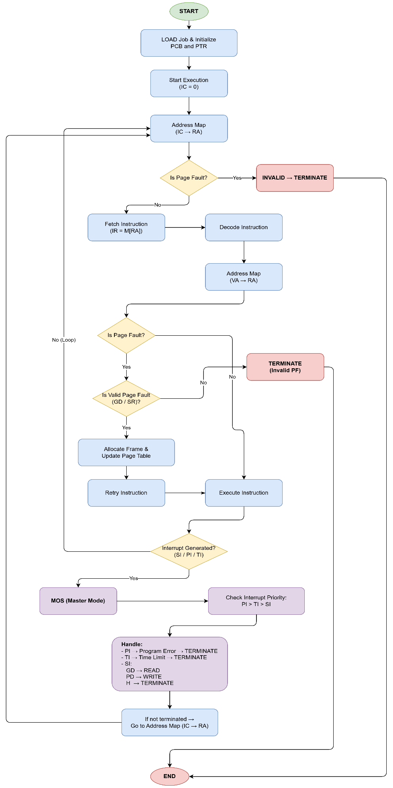
Program: -
#include <stdio.h>
#include <stdlib.h>
#include <string.h>
#include <time.h>

char M[300][4];
char IR[4], R[4];
char C = 'F';
int IC = 0;
int SI, PI, TI;
int PTR;
int TTC, LLC;
int TTL, TLL;
char jobID[5];
int frameUsed[30];
int pageTable[10];
int faultAddr;
int faultOnOperand;
int running;

FILE *fin, *fout;

void clearFrame(int f)
{
int base = f * 10;
int i, j;
for (i = 0; i < 10; i++)
for (j = 0; j < 4; j++)
M[base + i][j] = ' ';
}

int getFrame()
{
int free[30], cnt = 0, i;
for (i = 0; i < 30; i++)
if (!frameUsed[i])
free[cnt++] = i;
if (cnt == 0)
return -1;
int f = free[rand() % cnt];
frameUsed[f] = 1;
clearFrame(f);
return f;
}

int addrMap(int va)
{
if (va < 0 || va > 99)
{
PI = 2;
return -1;
}
int pg = va / 10;
int off = va % 10;
if (pageTable[pg] == -1)
{
PI = 3;
return -1;
}
return pageTable[pg] * 10 + off;
}

int allocPage(int va)
{
int pg = va / 10;
if (pageTable[pg] != -1)
return 1;
int f = getFrame();
if (f < 0)
return 0;
pageTable[pg] = f;
int e = PTR * 10 + pg;
M[e][0] = '1';
M[e][1] = ' ';
M[e][2] = '0' + f / 10;
M[e][3] = '0' + f % 10;
return 1;
}

void freeJobMemory()
{
int i;
for (i = 0; i < 10; i++)
{
if (pageTable[i] != -1)
{
frameUsed[pageTable[i]] = 0;
clearFrame(pageTable[i]);
pageTable[i] = -1;
}
}
if (PTR != -1)
{
frameUsed[PTR] = 0;
clearFrame(PTR);
PTR = -1;
}
}

char *errMsg[] = {
"NORMAL TERMINATION",
"ERROR: OUT OF DATA",
"ERROR: LINE LIMIT EXCEEDED",
"ERROR: TIME LIMIT EXCEEDED",
"ERROR: OPERATION CODE ERROR",
"ERROR: OPERAND ERROR",
"ERROR: INVALID PAGE FAULT"};

void terminate(int e1, int e2)
{
fprintf(fout, "\n\n");
fprintf(fout, "Job ID : %s\n", jobID);
if (e2 == -1)
fprintf(fout, "EM : %d - %s\n", e1, errMsg[e1]);
else
fprintf(fout, "EM : %d,%d - %s | %s\n", e1, e2, errMsg[e1], errMsg[e2]);
freeJobMemory();
running = 0;
}

void MOS()
{
int va, ra, i, j;
char buf[128];

if (PI == 1)
{
(TI == 2) ? terminate(3, 4) : terminate(4, -1);
return;
}
if (PI == 2)
{
(TI == 2) ? terminate(3, 5) : terminate(5, -1);
return;
}
if (PI == 3)
{
if (TI == 2)
{
terminate(3, -1);
return;
}
if (faultOnOperand && ((IR[0] == 'G' && IR[1] == 'D') || (IR[0] == 'S' && IR[1] == 'R')))
{
if (!allocPage(faultAddr))
{
terminate(6, -1);
return;
}
PI = 0;
faultOnOperand = 0;
return;
}
terminate(6, -1);
return;
}

if (SI == 1)
{
if (TI == 2)
{
terminate(3, -1);
return;
}
if (fgets(buf, 128, fin) == NULL || strncmp(buf, "$END", 4) == 0)
{
terminate(1, -1);
return;
}
buf[strcspn(buf, "\n")] = '\0';
int len = strlen(buf);
while (len < 40)
buf[len++] = ' ';
buf[40] = '\0';

if (IR[2] < '0' || IR[2] > '9' || IR[3] < '0' || IR[3] > '9')
{
terminate(5, -1);
return;
}
va = (IR[2] - '0') * 10 + (IR[3] - '0');

int k = 0;
for (i = 0; i < 10; i++)
{
PI = 0;
ra = addrMap(va + i);
if (PI == 3)
{
if (!allocPage(va + i))
{
terminate(6, -1);
return;
}
PI = 0;
ra = addrMap(va + i);
}
if (ra < 0)
{
terminate(5, -1);
return;
}
for (j = 0; j < 4; j++)
M[ra][j] = buf[k++];
}
PI = 0;
SI = 0;
return;
}

if (SI == 2)
{
LLC++;
if (IR[2] < '0' || IR[2] > '9' || IR[3] < '0' || IR[3] > '9')
{
terminate(5, -1);
return;
}
va = (IR[2] - '0') * 10 + (IR[3] - '0');

if (TI == 2)
{
for (i = 0; i < 10; i++)
{
PI = 0;
ra = addrMap(va + i);
if (ra < 0)
{
for (j = 0; j < 4; j++)
fputc(' ', fout);
}
else
{
for (j = 0; j < 4; j++)
fputc(M[ra][j], fout);
}
}
fputc('\n', fout);
PI = 0;
terminate(3, -1);
return;
}

if (LLC > TLL)
{
terminate(2, -1);
return;
}

for (i = 0; i < 10; i++)
{
PI = 0;
ra = addrMap(va + i);
if (ra < 0)
{
for (j = 0; j < 4; j++)
fputc(' ', fout);
}
else
{
for (j = 0; j < 4; j++)
fputc(M[ra][j], fout);
}
}
fputc('\n', fout);
PI = 0;
SI = 0;
return;
}

if (SI == 3)
{
terminate(0, -1);
return;
}

if (TI == 2)
terminate(3, -1);
}

void executeUserProgram()
{
int va, ra;
int i;

while (running)
{
SI = 0;
PI = 0;
faultOnOperand = 0;
faultAddr = -1;

ra = addrMap(IC);
if (PI != 0)
{
// fetch page fault - always invalid in this design
}
else
{
for (i = 0; i < 4; i++)
IR[i] = M[ra][i];
IC++;

if (IR[0] == 'H')
{
SI = 3;
}
else if (
(IR[0] == 'L' && IR[1] == 'R') ||
(IR[0] == 'S' && IR[1] == 'R') ||
(IR[0] == 'C' && IR[1] == 'R') ||
(IR[0] == 'B' && IR[1] == 'T') ||
(IR[0] == 'G' && IR[1] == 'D') ||
(IR[0] == 'P' && IR[1] == 'D'))
{
if (IR[2] < '0' || IR[2] > '9' || IR[3] < '0' || IR[3] > '9')
{
PI = 2;
IC--;
}
else
{
va = (IR[2] - '0') * 10 + (IR[3] - '0');
ra = addrMap(va);
if (PI != 0)
{
IC--;
if (PI == 3)
{
faultOnOperand = 1;
faultAddr = va;
}
}
else
{
if (IR[0] == 'L' && IR[1] == 'R')
for (i = 0; i < 4; i++)
R[i] = M[ra][i];
else if (IR[0] == 'S' && IR[1] == 'R')
for (i = 0; i < 4; i++)
M[ra][i] = R[i];
else if (IR[0] == 'C' && IR[1] == 'R')
{
C = 'T';
for (i = 0; i < 4; i++)
if (R[i] != M[ra][i])
{
C = 'F';
break;
}
}
else if (IR[0] == 'B' && IR[1] == 'T')
{
if (C == 'T')
IC = va;
}
else if (IR[0] == 'G' && IR[1] == 'D')
SI = 1;
else if (IR[0] == 'P' && IR[1] == 'D')
SI = 2;
}
}
}
else
{
PI = 1; // invalid opcode
}
}

TTC++;
if (TTC == TTL)
TI = 2;

if (SI || PI || TI)
MOS();
}
}

int parseNum(char *s, int n)
{
int v = 0, i;
for (i = 0; i < n; i++)
if (s[i] >= '0' && s[i] <= '9')
v = v * 10 + (s[i] - '0');
return v;
}

void load()
{
char line[128];
int pageNum;

fin = fopen("input.txt", "r");
fout = fopen("output.txt", "w");
if (!fin || !fout)
{
printf("file open error\n");
return;
}

memset(frameUsed, 0, sizeof(frameUsed));
for (int i = 0; i < 300; i++)
for (int j = 0; j < 4; j++)
M[i][j] = ' ';
srand(time(NULL));

while (fgets(line, sizeof(line), fin))
{
line[strcspn(line, "\n")] = '\0';

if (strncmp(line, "$AMJ", 4) == 0)
{
for (int i = 0; i < 10; i++)
pageTable[i] = -1;
for (int i = 0; i < 4; i++)
{
IR[i] = ' ';
R[i] = ' ';
}
IC = 0;
C = 'F';
SI = 0;
TI = 0;
PI = 0;
TTC = 0;
LLC = 0;
running = 0;
faultAddr = -1;
faultOnOperand = 0;
pageNum = 0;

strncpy(jobID, line + 4, 4);
jobID[4] = '\0';
TTL = parseNum(line + 8, 4);
TLL = parseNum(line + 12, 4);

PTR = getFrame();
int base = PTR * 10;
for (int i = 0; i < 10; i++)
{
M[base + i][0] = '0';
M[base + i][1] = ' ';
M[base + i][2] = '*';
M[base + i][3] = '*';
}
}
else if (strncmp(line, "$DTA", 4) == 0)
{
IC = 0;
running = 1;
executeUserProgram();
}
else if (strncmp(line, "$END", 4) == 0)
{
// nothing to do
}
else
{
if (pageNum >= 10)
continue;
int f = getFrame();
if (f < 0)
{
printf("no free frame\n");
continue;
}

pageTable[pageNum] = f;
int e = PTR * 10 + pageNum;
M[e][0] = '1';
M[e][1] = ' ';
M[e][2] = '0' + f / 10;
M[e][3] = '0' + f % 10;

int len = strlen(line);
while (len < 40)
line[len++] = ' ';
line[40] = '\0';

int base = f * 10, k = 0;
for (int i = 0; i < 10; i++)
for (int j = 0; j < 4; j++)
M[base + i][j] = line[k++];

pageNum++;
}
}

fclose(fin);
fclose(fout);
}

int main()
{
load();
printf("done. check output.txt\n");
return 0;
}
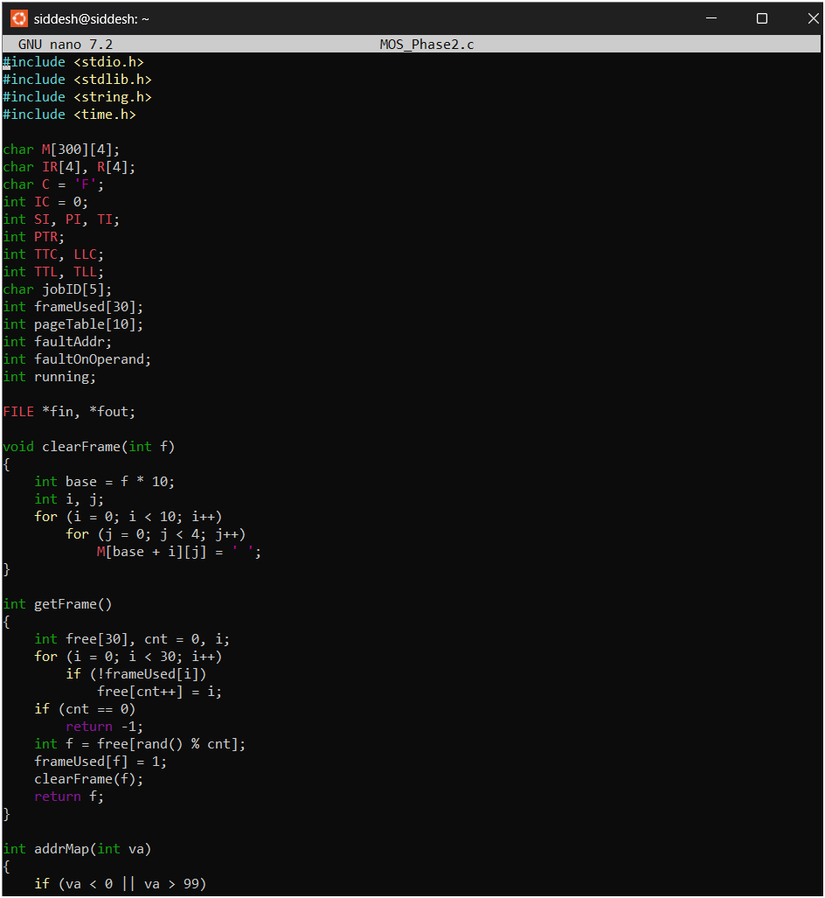
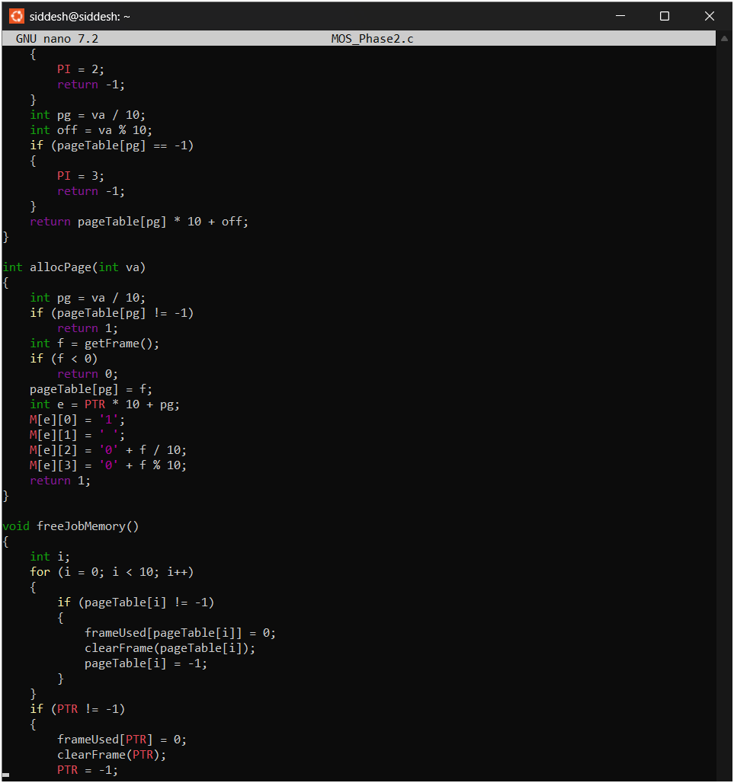
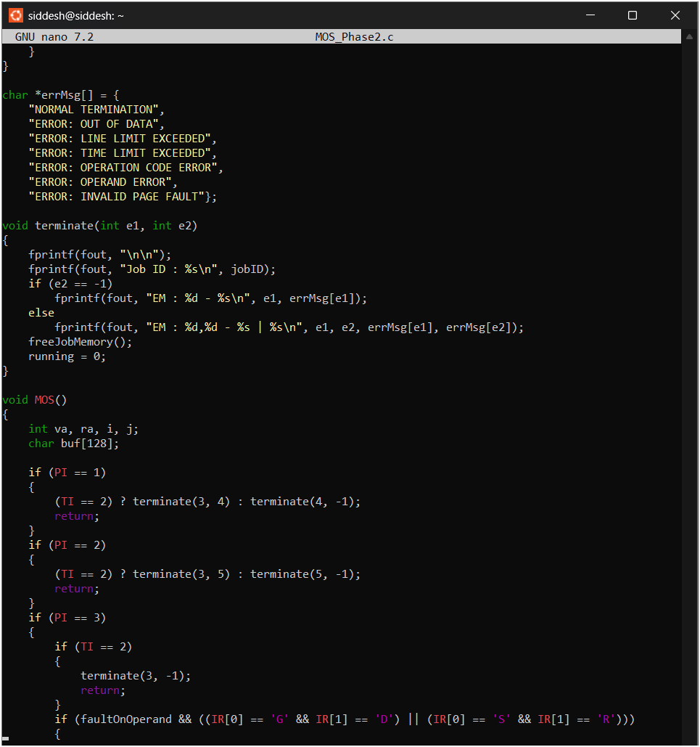
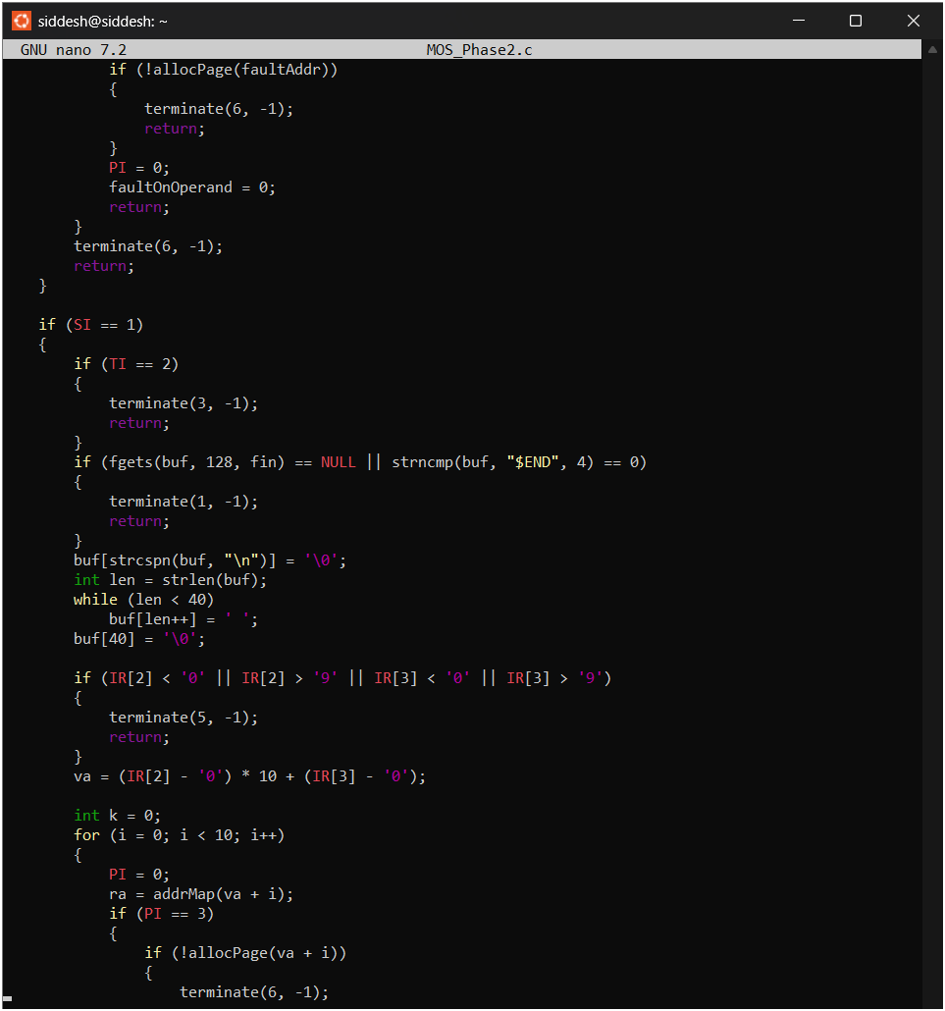
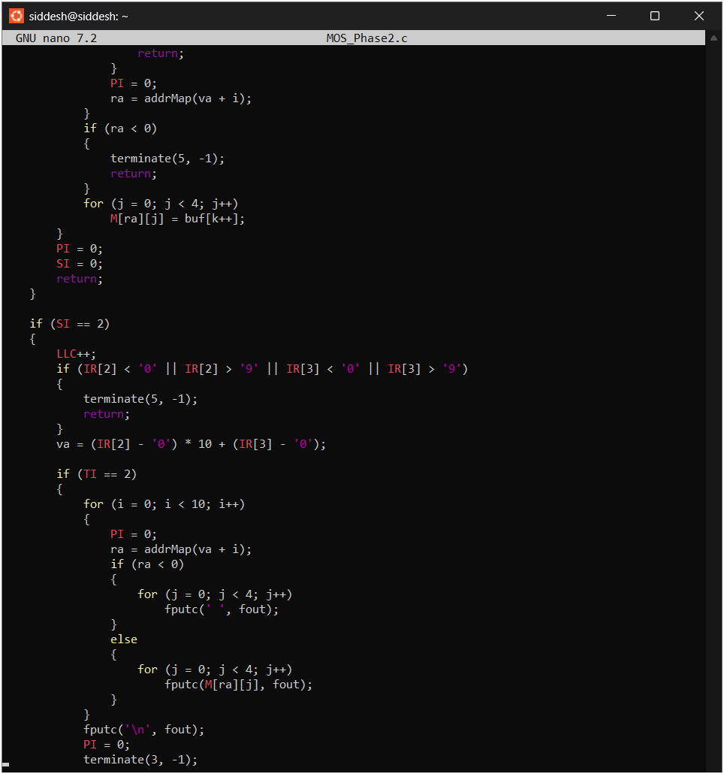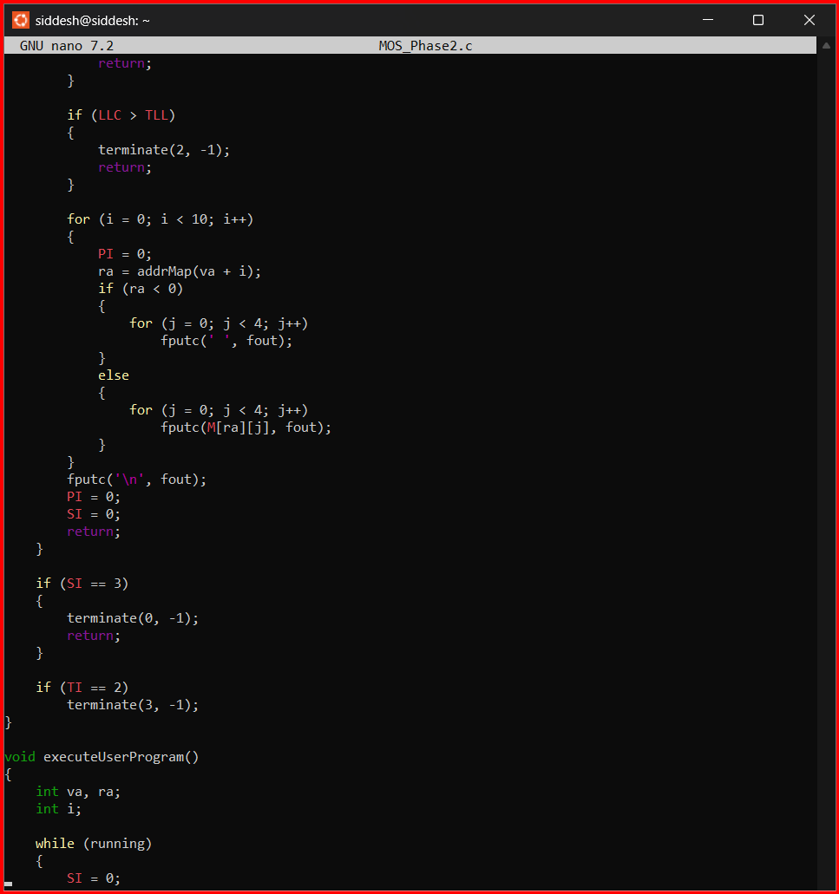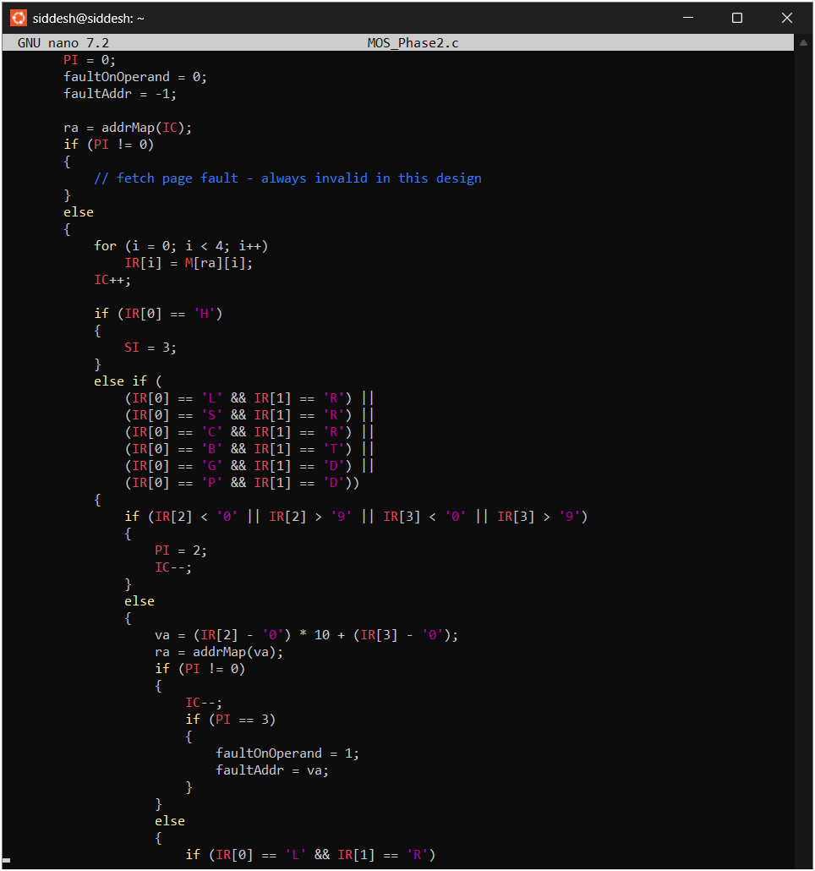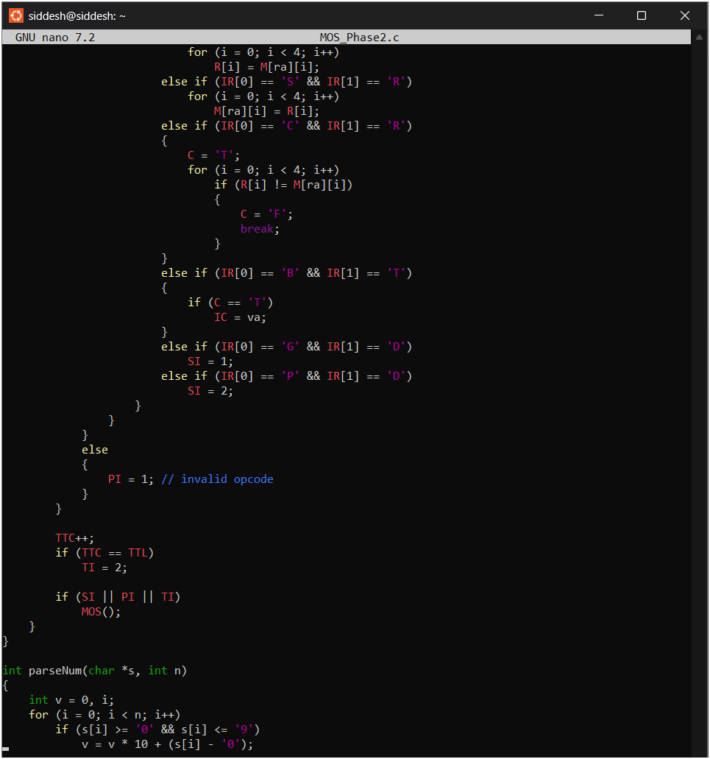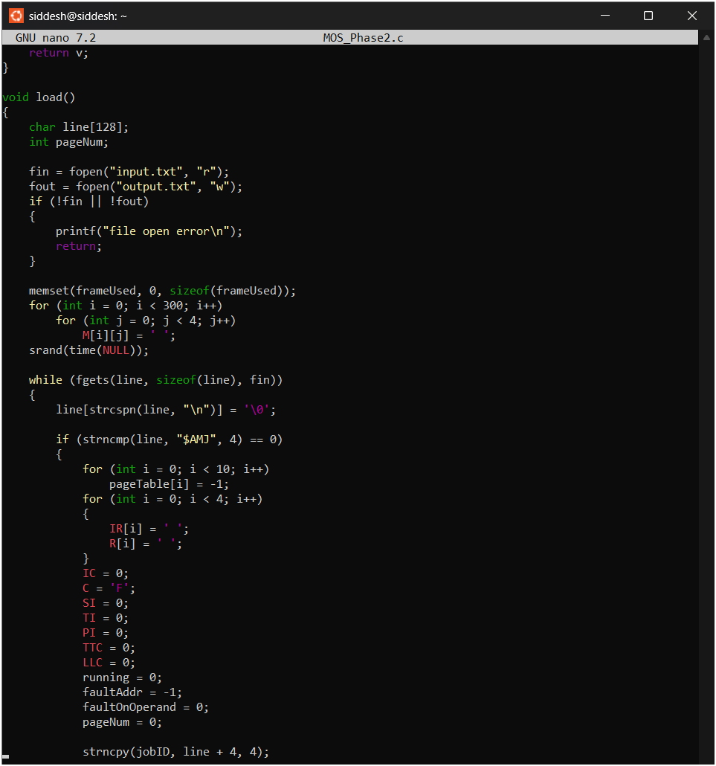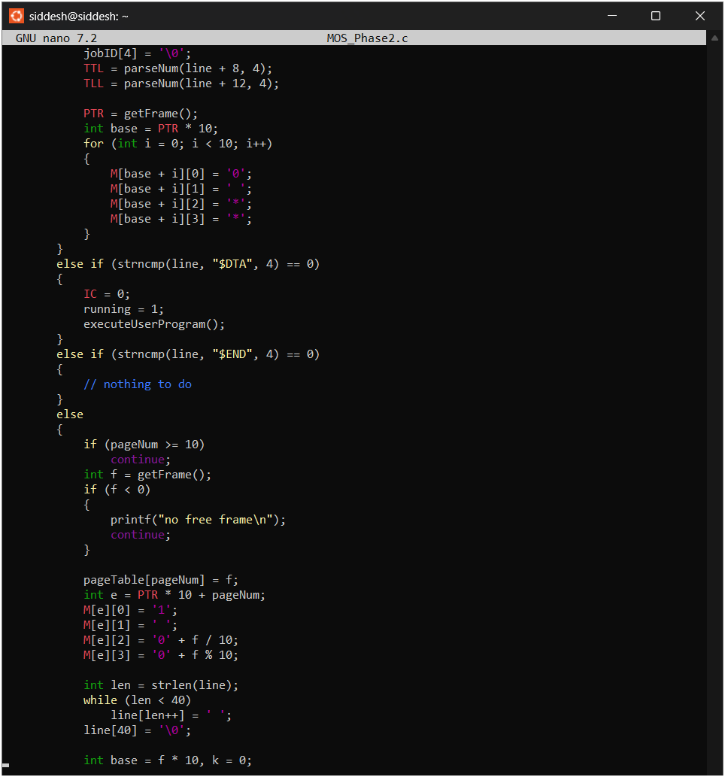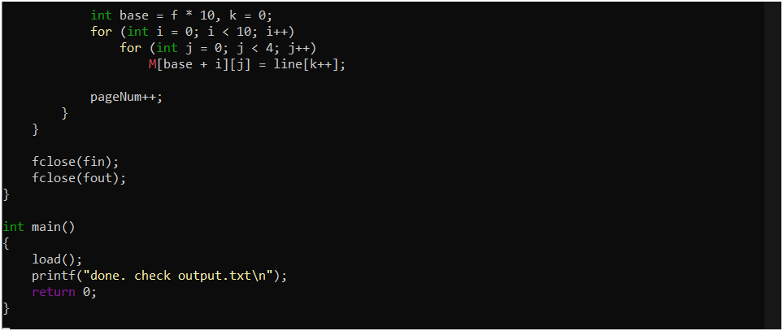
Input:-

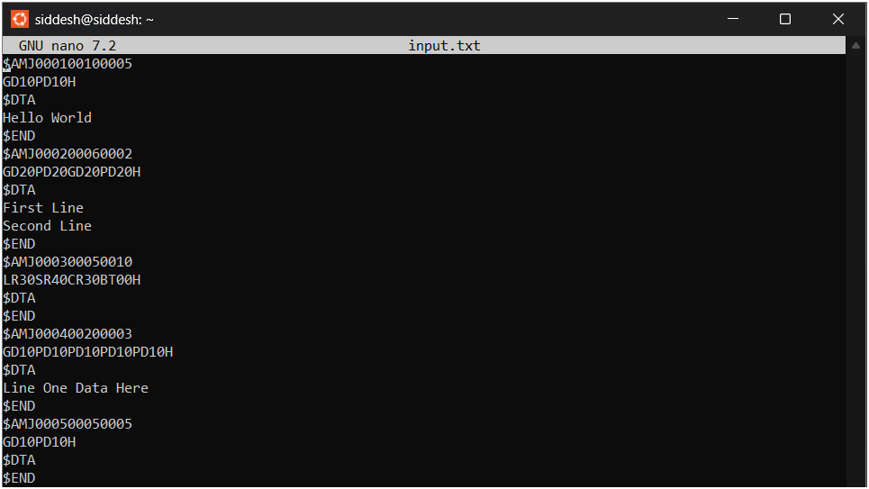
Output:-
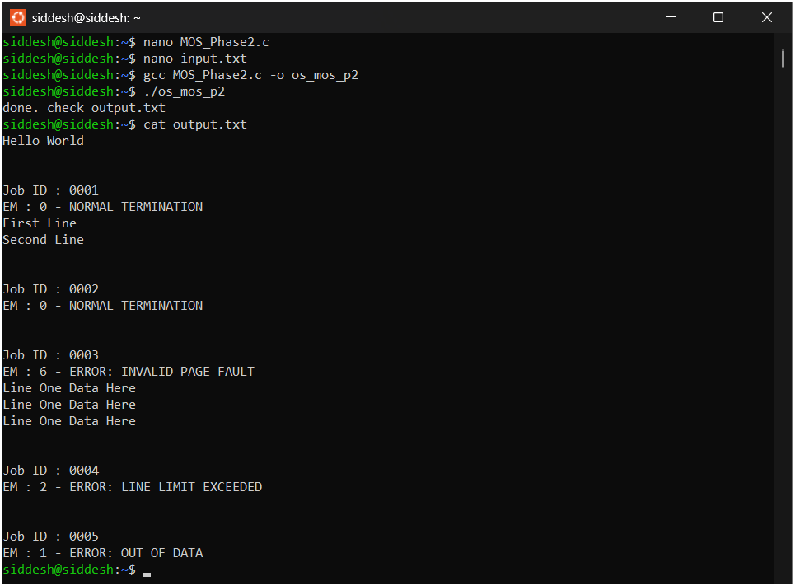

Conclusion:-
The MOS Phase-2 project successfully demonstrates advanced operating system concepts such as paging, virtual memory, and interrupt handling. It shows how address translation is performed using page tables and how system errors and execution limits are managed efficiently. This phase provides a strong foundation for understanding real-world operating system behavior.

